|  |  |
| --- | --- |
| Edith Cowan University School of Science |  |

Workshop 8

C++ Classes

**Related Objectives:**

* Create classes
* Learn about encapsulating class components
* Implement class functions
* Use private functions and public data
* Use the scope resolution operator with class fields and functions
* Use static class members
* Learn about the this pointer
* Understand the advantages of polymorphism

**Activity:**

In the below tasks, using separate .CPP and .H files create a program which makes use of the class declared.

1. Write, compile and run the following program outlined below

class CollegeCourse {

private:

string department;

int courseNum;

int seats;

public:

void setDepartmentAndCourse(string, int);

void setSeats(int);

void displayCourseData();

};

1. Using a static field write, compile and run the following program outlined below. Pay attention to the static fields. This program should print a letter in the main method.

class Letter {

private:

string title;

string recipient;

static int count;

public:

void setRecipient(string, string);

void displayGreeting();

static void displayCount();

};

1. Extend the HR system from Workshop 6. There is a new text file on blackboard (employees.txt) containing:

* Employee number.
* Name.
* Role.
* Payrate.

Write a program that reads the file in and stores the records in an object of the HRSystem class. This class should contain a vector of Employee objects to hold the records, and methods to manage them.

To verify that the file has been read, the program should first print a list of all employees, then just the managers, then just the workers. This should be followed by a menu that lets a user look up an employees pay rate by partially entering their name.

The output should be similar to this:

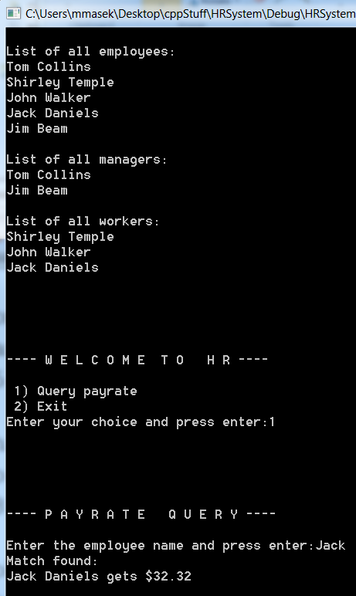

The following example structure is given to give you some hints (with a full solution on blackboard):

main.cpp:

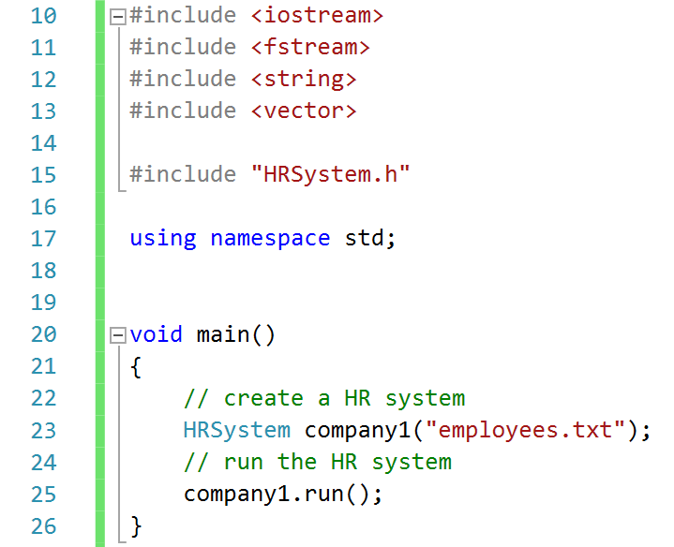

Employee.h:

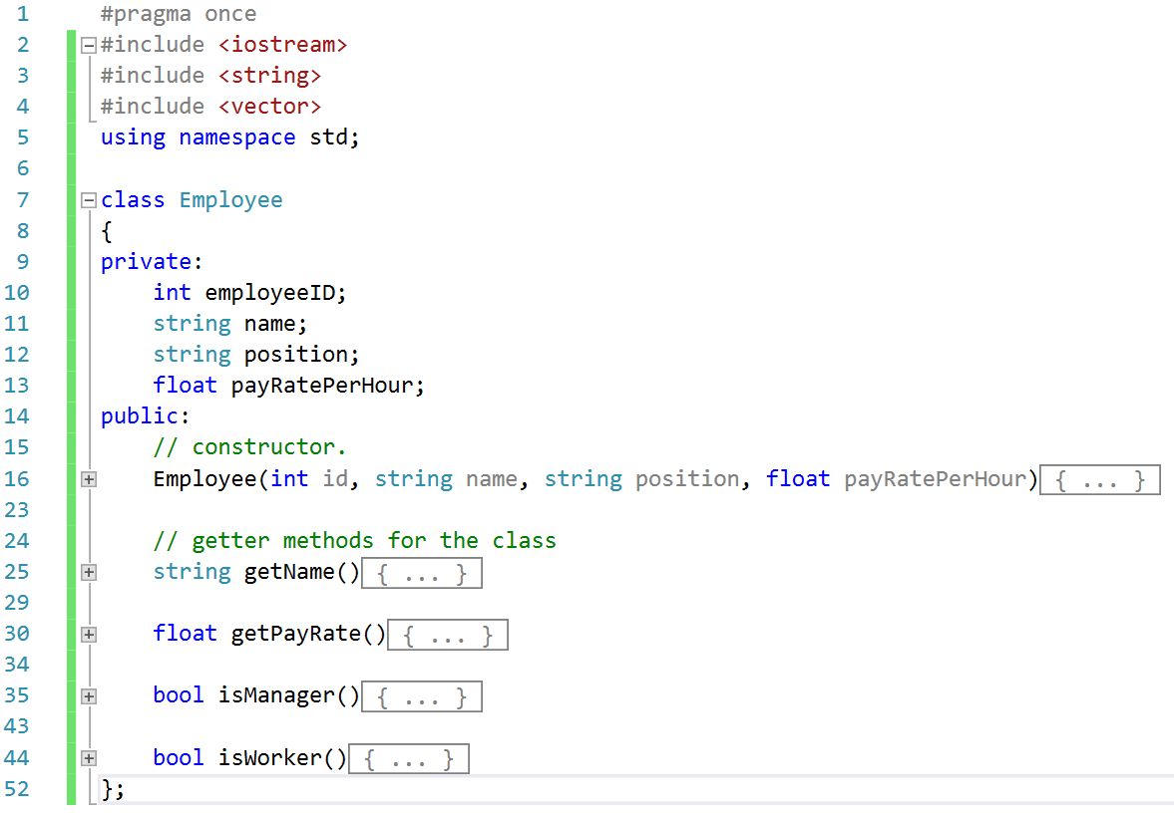

HRSystem.h:

